|  |  |
| --- | --- |
| **Name:** | Bodhisatya Ghosh |
| **Branch:** | CSE – Data Science |
| **Batch:** | B |
| **Course:** | Soft Computing |
| **Experiment no:** | 8 |

**Aim:** To design and implement fuzzy controller for a given problem.

**Theory:** A fuzzy controller is a type of control system that utilizes fuzzy logic to emulate human decision-making. Fuzzy logic is an extension of classical (or Boolean) logic that allows for a more nuanced and flexible approach to reasoning and decision-making in the presence of uncertainty. Fuzzy controllers are widely used in various applications, including industrial control systems, consumer electronics, and automated systems. Fuzzy controllers are used in a variety of applications, such as temperature control systems, speed control in vehicles, decision support systems, and more.

**REAL TIME APPLICATION USED:**

I have implemented a basic fuzzy logic system for deciding whether to open, close, or remain undecided about opening an umbrella based on rain and wind conditions.

1. Fuzzy Sets:

* You define fuzzy sets for "Rain" and "Wind," each with different degrees of membership. For example, "Slight Rain" and "Heavy Rain" are fuzzy sets for rain, and "Weak Wind" and "Strong Wind" are fuzzy sets for wind. These sets are defined using triangular membership functions.

1. Fuzzification:
   * Fuzzification is the process of converting crisp inputs (rain and wind values) into fuzzy sets. The fuzz.trimf function is used to create triangular membership functions for rain and wind conditions.
2. Fuzzy Rules:
   * Two fuzzy rules are defined based on rain and wind conditions:
     + Rule 1: If rain is slight and wind is weak, then there is a preference to open the umbrella.
     + Rule 2: If rain is heavy or wind is strong, then there is a preference to close the umbrella.
3. Fuzzy Inference:
   * Fuzzy inference is the process of determining the degree to which each fuzzy rule contributes to the overall decision. This is done using the fuzz.interp_membership function, which calculates the membership values for the input conditions in each rule.
4. Rule Activation:
   * The membership values obtained from fuzzification are used to activate each rule. These values represent the degree to which the conditions specified in each rule are satisfied.
5. Rule Combination:
   * The results of the two rules are combined using the np.fmax function, which takes the maximum degree of membership for each output value. This step determines the final fuzzy output for each possible decision.
6. Defuzzification:
   * The final fuzzy output is then defuzzified to obtain a crisp decision. The fuzz.defuzz function is used with the 'centroid' method, which calculates the center of mass of the combined fuzzy set.
7. Decision:
   * Based on the defuzzified result, a decision is made on whether to open the umbrella, close it, or remain undecided.

**Program:**

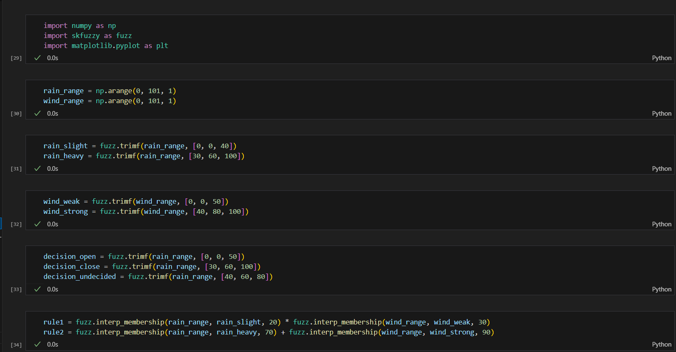

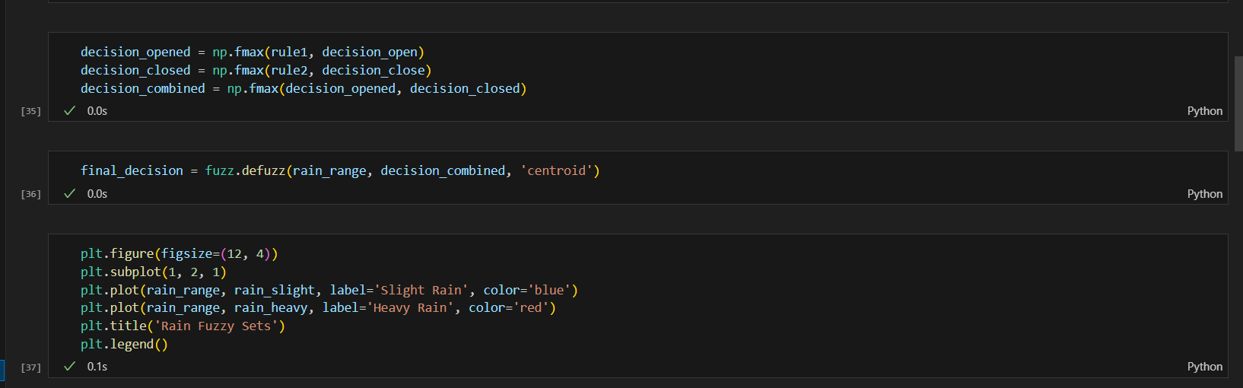

**Results:**

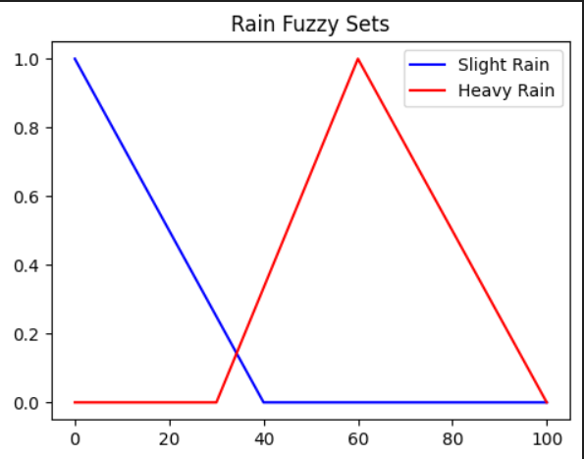

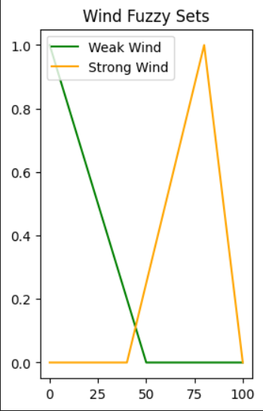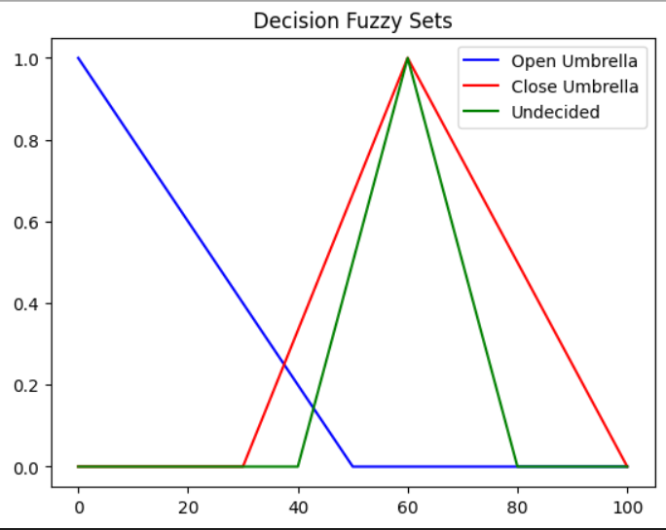

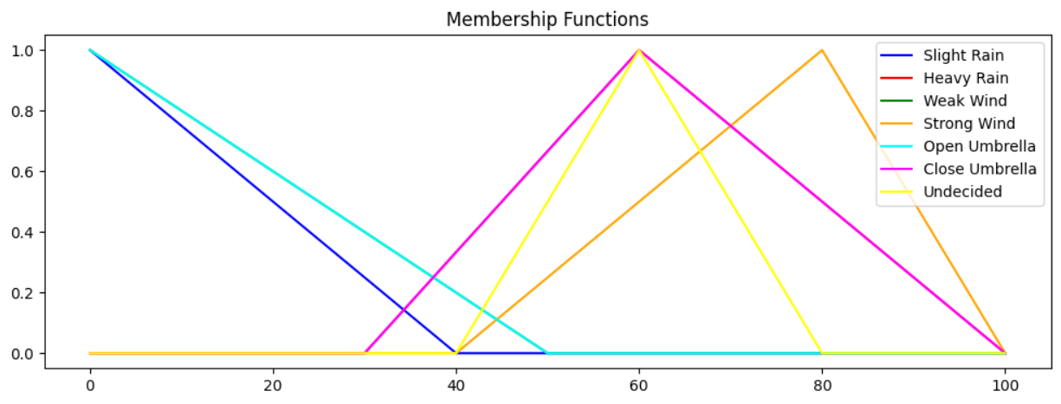

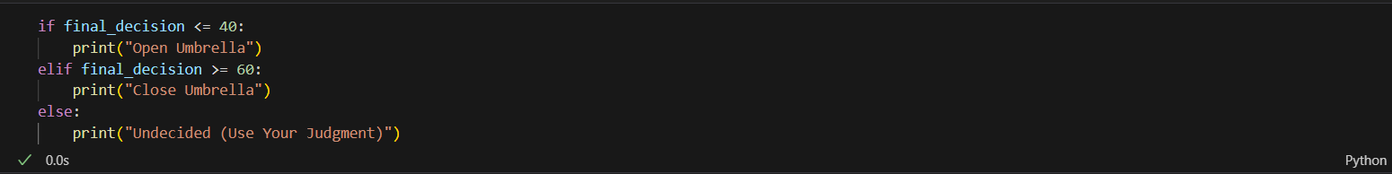

**CONCLUSION: -** In this experiment we have successfully implemented a Fuzzy Logic ControllerS